RFP assay

Lysis buffer:
5 mM K-PO4 buffer at pH 7.4 containing 0.5 mg/ml lysozyme and Benzonaze/Nuclease (1:1000 diluted)

Cell preparation/ lysis:
Cell suspension: Resuspend cells from 500 µL culture in 1500 µL of 5 mM K-PO4 buffer at pH 7.4 and incubate for 1h at 1350 rpm shaking at room temperature. Clear cell lysates by centrifugation for 10 min at 2500x g at room temperature.
- Transfer of 100 µL of each variant in quadruplicates into 96-well plates (flat bottom black for fluorescence measurement)

Fluorescence measurement:
AzamiRed1.0
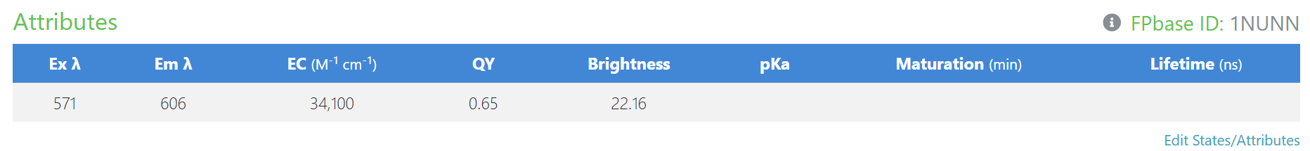
RagBFP
